End of semester summary
This semester my project focused on finding the relationship between particle properties and their discharge rates from laboratory scale hoppers. The research conduct in this project is important because of the wide spread use of hoppers in almost every industry. This research required the gathering of data from hopper discharge experiments, where different parameters were varied. These parameters included the hopper diameter, hopper material and particle size. Two of the hoppers used were made by 3D printing and one of the hoppers was blown out of glass by the ASU glass blowing facility. The 3D printed hopper were designed using Auto desk Fusion 360 drafting software. The 3D printed hoppers have a diameter of 9.5 cm and 12.5 cm and the glass hopper has a diameter of 9.5 cm. The particles used in these experiments are glass beads which have the following diameters, 0.6 mm, 2 mm and 4 mm. Glass beads were used because they represent the ideal case of a particle, being nearly perfectly spherical and have properties that can be easily measured and compared to literature measured values.
For data analysis I used python coupled with a python package called pandas. Pandas is package that gives the user a variety of tools commonly used in the field of data science. This allowed me to learn a lot about data clean up and the application of data science techniques. This has been very important in my personal development, because I hope to apply methods and tools commonly found in data science to my future chemical engineering career.
One of my future goals for this research project is to rerun my experiments under consistent conditions such as ensuring that each sample goes through the same washing procedure. The next goal is to evaluate my experimental method and standardize it so that experimental error can be reduced or accounted for. Once this is complete I will work on varying the parameters of the experiment, such as particle roughness and hopper roughness, by etching them with different sodium hydroxide solutions. The surface of the glass beads and hoppers will change due to the etching and a relationship between etching time, sodium hydroxide concentration, and etching solution agitation will be developed. This will be conducted by using a method called Design of Experiment. This is a method that is widely used in industry to run experiments efficiently and will give me hands on knowledge on a relevant skill found in industry.
This FURI project has taught me a lot about my own learning style and my own limits. I have learned that I work better when I ask questions frequently and I feel that is something that I did not do as much as I needed too, to reach my full potential this semester. This will also require me to conduct a lot more thorough inquiries into my research topic and implement discipline in conducting continues research on the subject by making it a habit in my own life. This project has also taught me that I have hard limits and can easily get burned out when taking on too many classes and extracurricular activities in addition to FURI. This, I feel, is one of the most important lessons I have learned from this project and going through this has given me the wherewithal to know what I can take on in my life in terms of school and still be successful.
In addition, I have learned of the need to be carful when making decisions, recording results and ensuring that what I are doing in one run of an experiment, is what I have been doing in all previous runs of an experiment. I have done this by double checking myself in my work and double checking my equipment. This habit has been learned the hard way through this project by the consequences of not ensuring what I are doing is the right way, and I feel that this has sharpened me into a better researcher, student and person.
This project has given me many valuable skills that I will be able to take into the work place, as well as acquainting me with my peers who have given me valuable advice and assistance on my road to becoming a chemical engineer. This project has shown me flaws in my own self but also how to correct these and that these flaws can be corrected.

All of my budget was spent by combining it with fellow FURI researcher in my lab’s funding, in order to buy a large quantity of glass beads that is critical to all our current and future research.
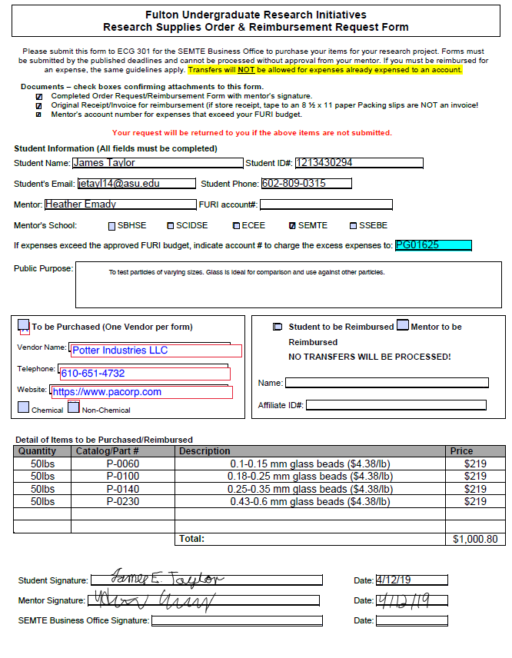

The following email was sent to business office and shows where my funding contributed to the purchase.
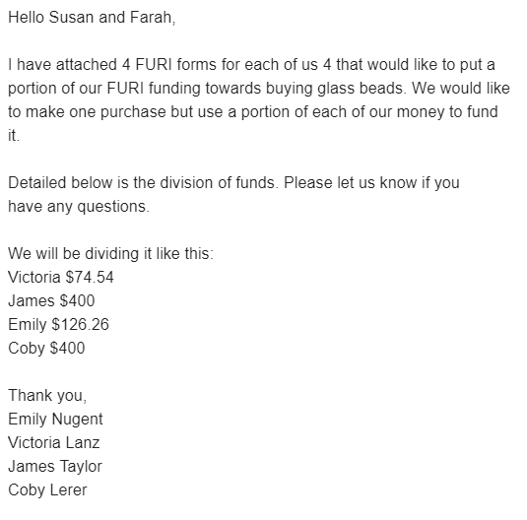

Mentor Approval
